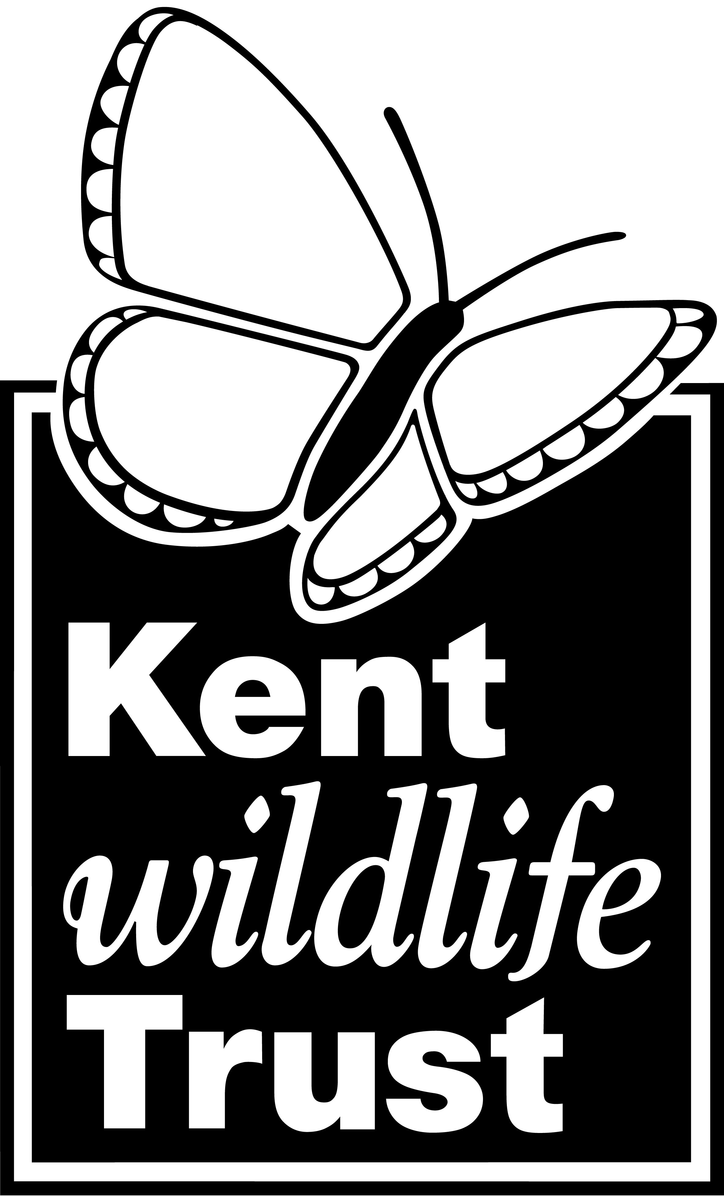

Summary of Proof of Evidence

Kent Wildlife Trust

Re: London Ashford Airport, Lydd, Romney Marsh, Kent

Y06/1647/SH: Erection of a terminal building (capable of processing
500,000 passengers per annum) and 637 car parking spaces

Y06/1648/SH: Construction of a 249m runway together with an additional
150m starter extension

Planning Inspectorate Refs:
APP/L2250/V/10/2131934
APP/L2250/V/10/2131936

Summary

- Dungeness has been long recognised as a site of major significance for biodiversity, and particularly for species associated with vegetated shingle and wetland habitats. Its importance is discussed by a number of authors, who note the very substantial importance of its invertebrate fauna, and the presence at Dungeness of extensive habitat areas not found on other shingle sites in the UK.

- Planning policy at national, regional and local level establishes that important habitats and species are to be protected through planning policy, and that harm to important habitats and species should not be permitted except where there is over-riding need which outweighs the importance of any impact.

- Policy also establishes the importance of adaptation to climate change. In the case of biodiversity, national guidance indicates that such adaptation requires protection of existing biodiversity, together with the reduction of sources of harm not related to climate change, including nutrient enrichment.

- A suite of rare and threatened plant species occur in areas which, it is understood from the planning documents, would be affected by the proposals. Some of these species have been confirmed as being present through site surveys carried out by the applicant; however these surveys are very limited in scope, and further rare and threatened species may also be affected.

- Some of these plant species have undergone major population declines at national level, and are classed as endangered and even critically endangered.

- This list of plant species which would potentially be affected by the development proposals includes species known to be susceptible to increased soil fertility, and whose national decline may be due to nutrient enrichment. It is not possible to use critical loads to identify ‘safe’ levels of nitrogen deposition for individual species.

- An even longer list of rare and threatened invertebrates occurs in areas likely to be affected by the development proposals. However, the survey of invertebrates is again inadequate, and many more species may also be affected. For example, no survey was carried out of spiders, even though the shingle habitats of Dungeness are known to support a number of important spider species.

- More than a score of the important invertebrate species are associated with shingle habitats or with plants of the shingle habitats.

- The development proposals affect a relatively large proportion of the remaining shingle vegetation at Dungeness which is in favourable condition. Potentially significant impacts arise from direct habitat change, nitrogen deposition, and, in the case of moths, increased lighting at night.

- Any impact upon the shingle habitats and species of Dungeness needs to be considered in the light of the very substantial historic loss of this habitat at Dungeness and elsewhere on the south coast. This includes the destruction of nearly 60% of Dungeness’s shingle vegetation in the 40 years to 1985.

- Little data is available which allows assessment of recent change in species’ populations at Dungeness. However, the data available suggests that populations of some moth and plant species have declined at Dungeness over recent decades. It does not appear to be safe to conclude that existing activities or environmental pressures at Dungeness have not had or are not having a negative impact.

- Proposed mitigation measures, including the Airfield Biodiversity Action Plan are inadequate and unproven, not least because of the lack of biological information which would be necessary to inform any proposed mitigation.

- There is therefore a very real risk that, should the development go ahead, it will result in substantial, negative impacts on biodiversity. The impacts of the development proposals on biodiversity are potentially of national or international significance, because of the importance of the species at Dungeness, the ongoing threats which these species already face, and the already very reduced availability of habitat due to past losses.

- These potential impacts are clearly not outweighed by the need for the proposed development, which is only of local significance. The proposals therefore fail to meet the tests set out in national, regional and local planning policy.

